Registration ID: 260640160209
PNR: 260740150018
Name: PRATIK SUNIL ABHANG
Q.1. Your company's IP address is 192.168.10.0/24. You need to create subnets for four departments with host requirements of 120, 30, 60, 14 and 6. Calculate the network address, subnet mask, usable host range, and broadcast address for each department.
Department/Site | Hosts | Network Address | Subnet Mask | Usable Host Range | Broadcast
Department 1 | 120 | 192.168.10.0/25 | 255.255.255.128 | 192.168.10.1 – 192.168.10.126 | 192.168.10.127
Department 3 | 60 | 192.168.10.128/26 | 255.255.255.192 | 192.168.10.129 – 192.168.10.190 | 192.168.10.191
Department 2 | 30 | 192.168.10.192/27 | 255.255.255.224 | 192.168.10.193 – 192.168.10.222 | 192.168.10.223
Department 4 | 14 | 192.168.10.224/28 | 255.255.255.240 | 192.168.10.225 – 192.168.10.238 | 192.168.10.239
Department 5 | 6 | 192.168.10.240/29 | 255.255.255.248 | 192.168.10.241 – 192.168.10.246 | 192.168.10.247
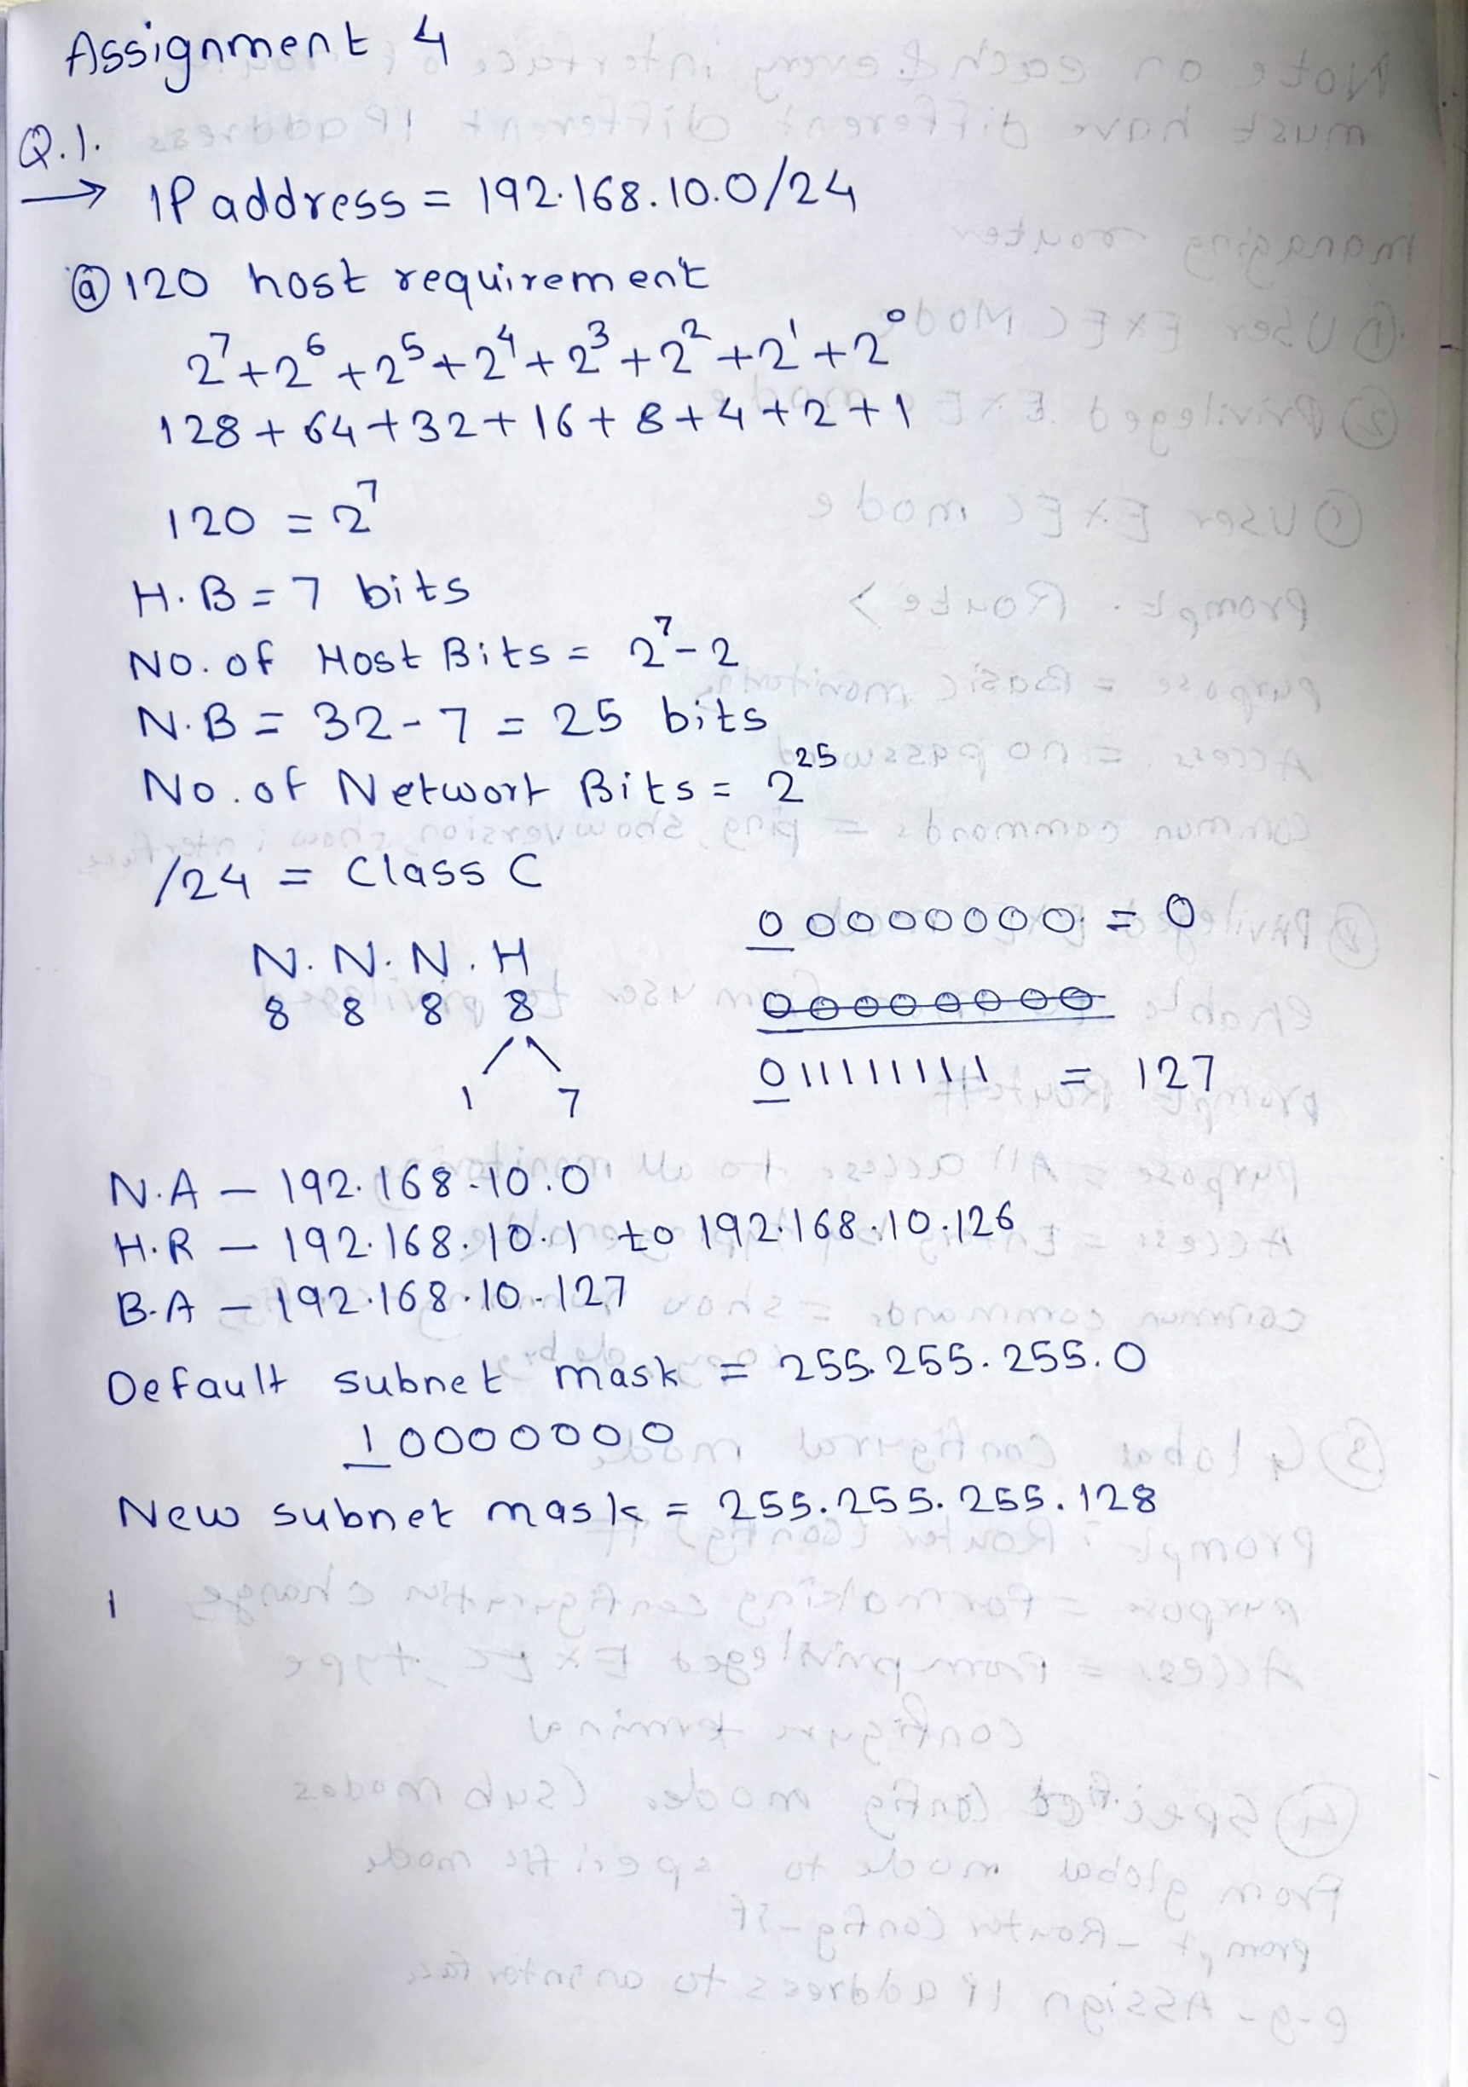
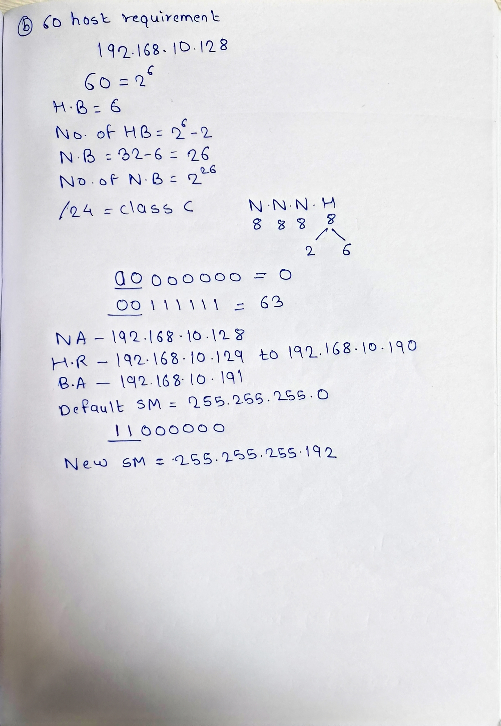
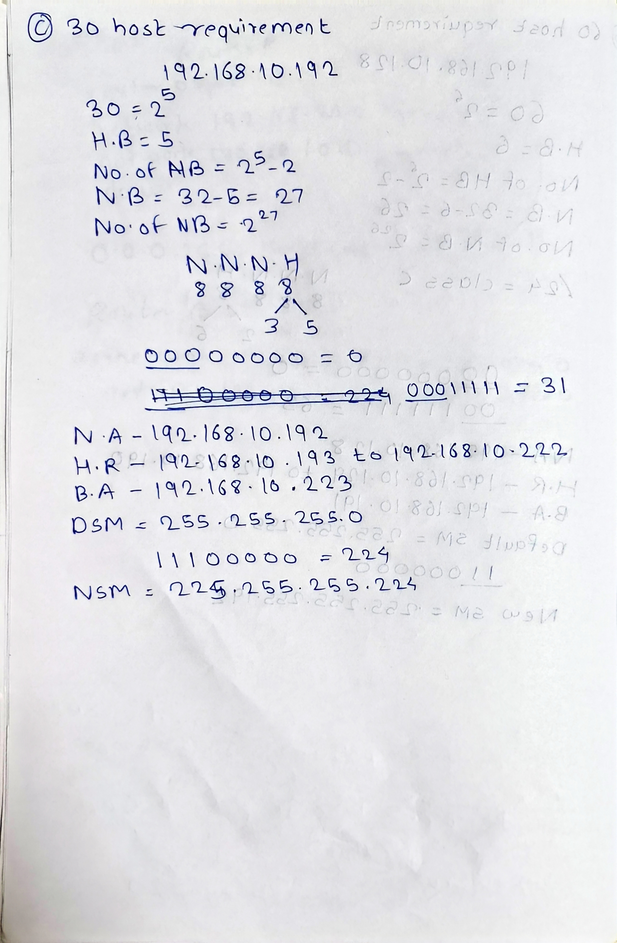
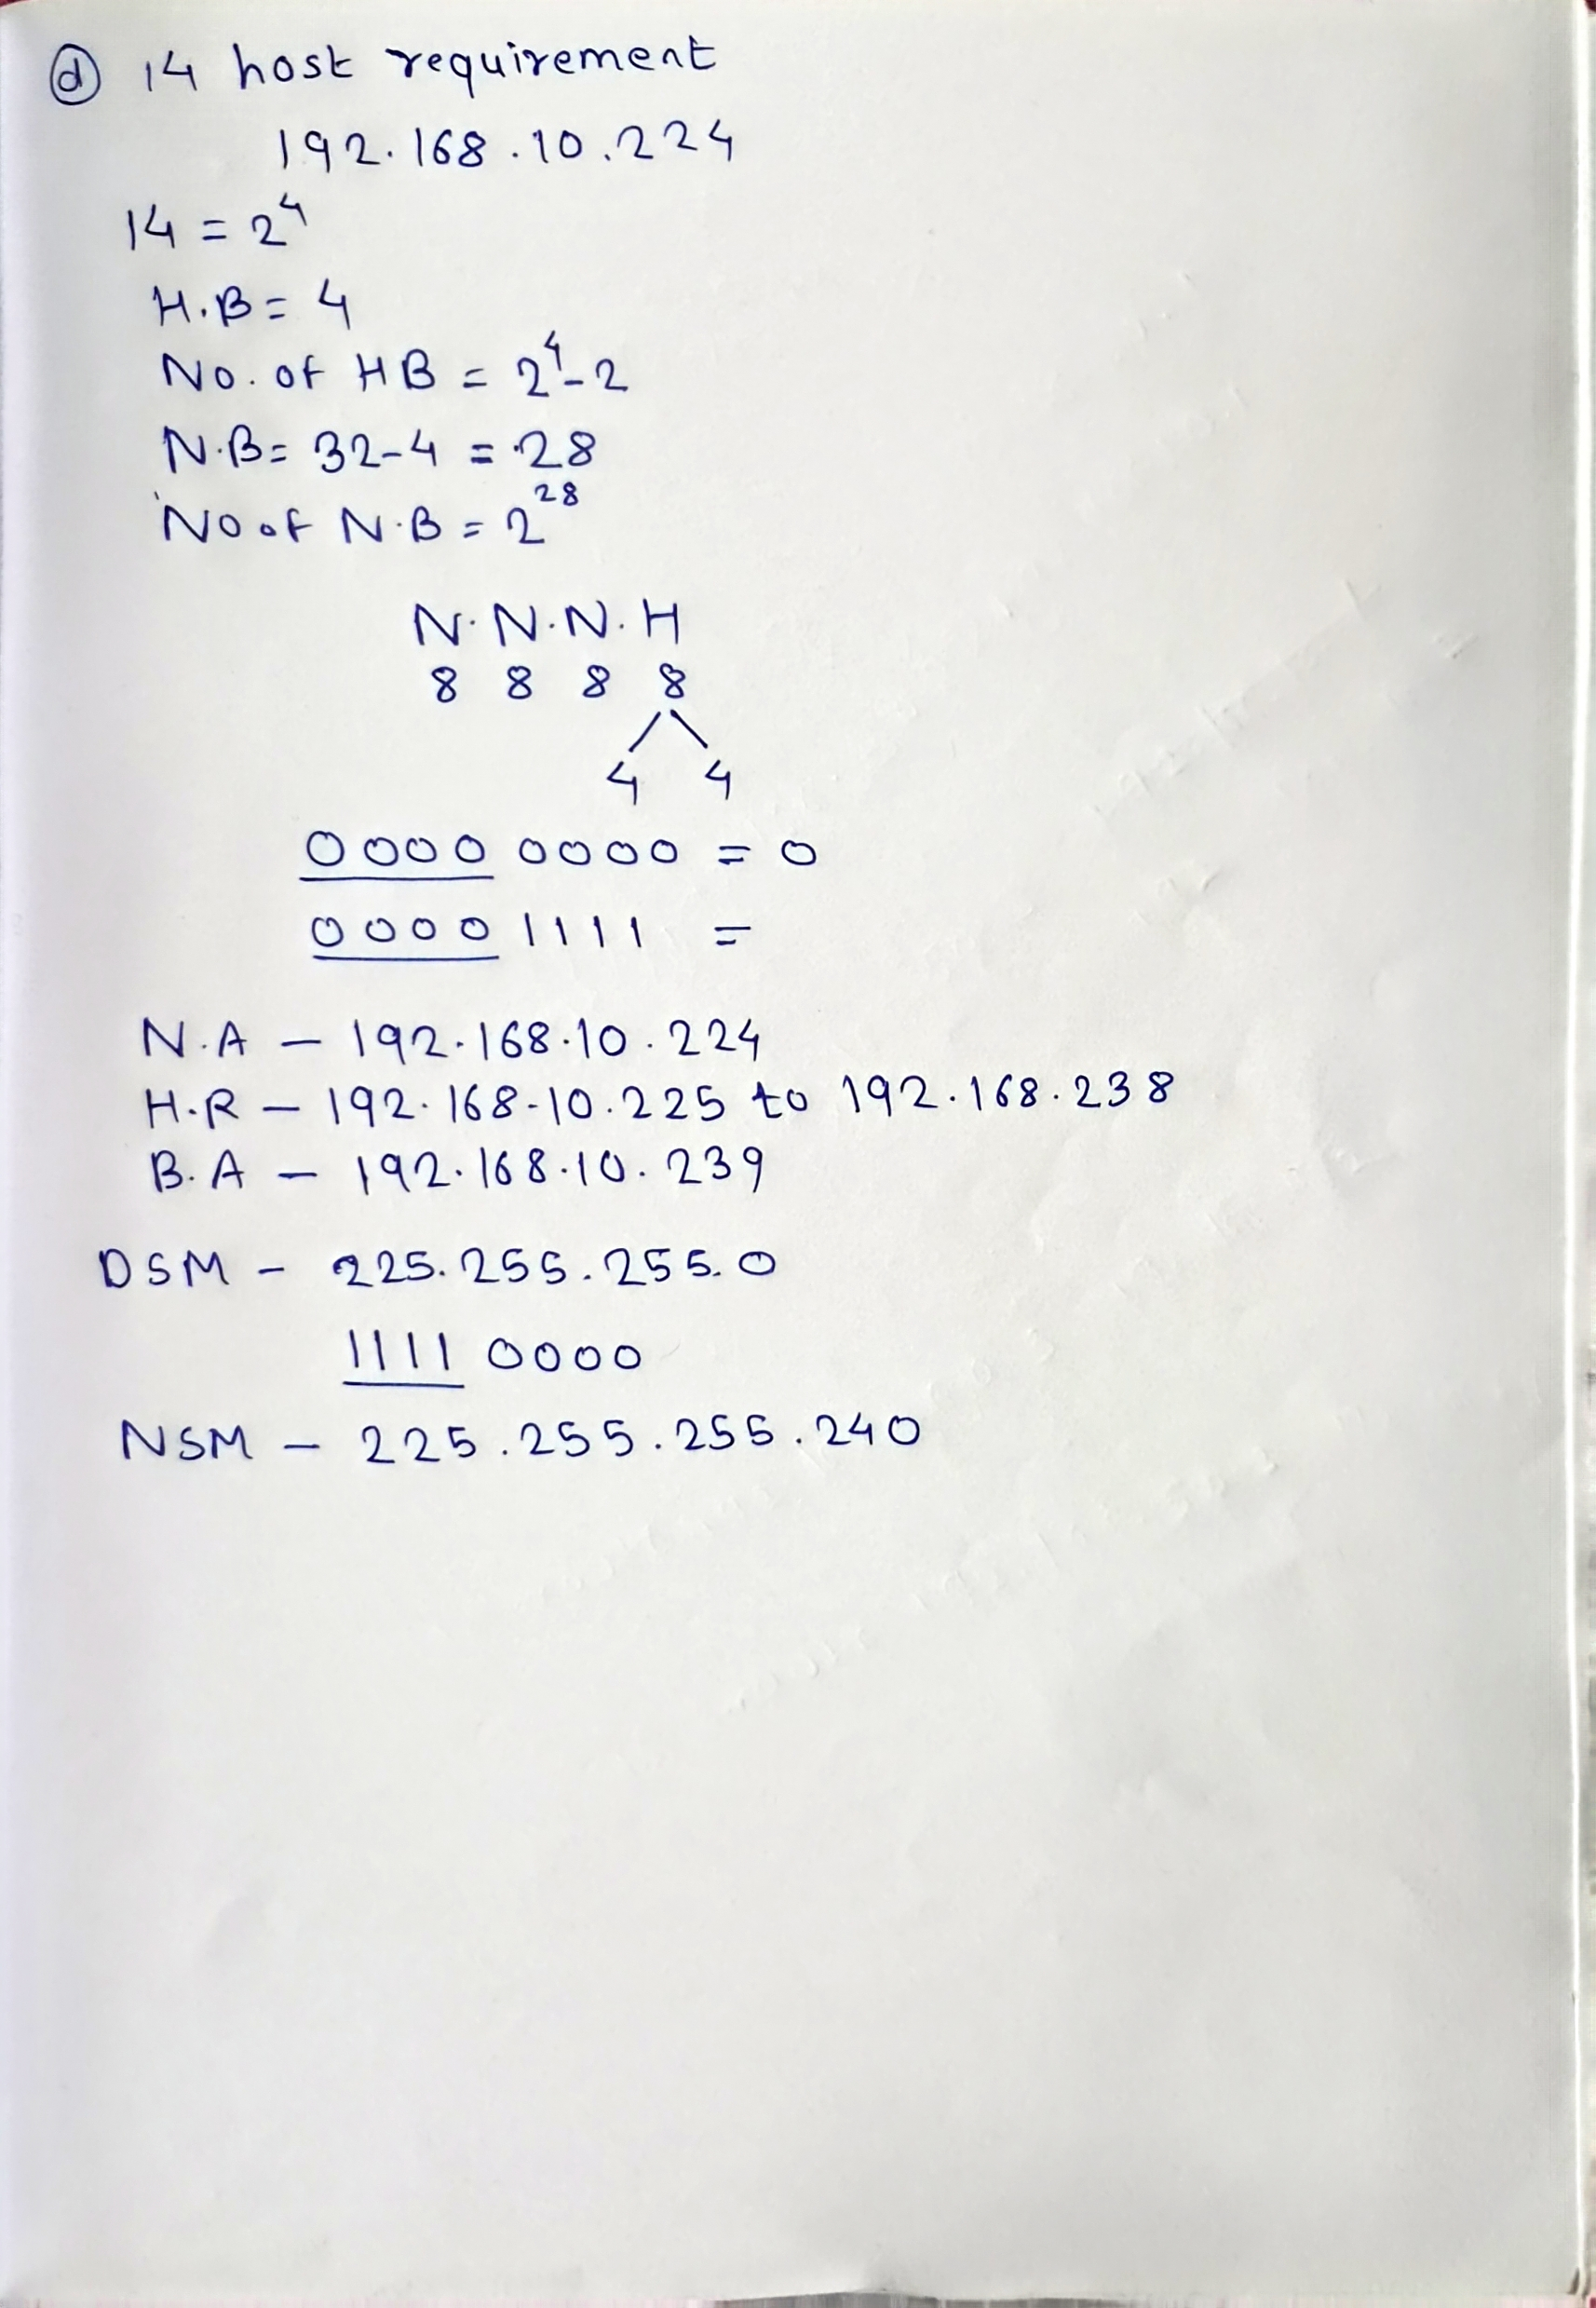
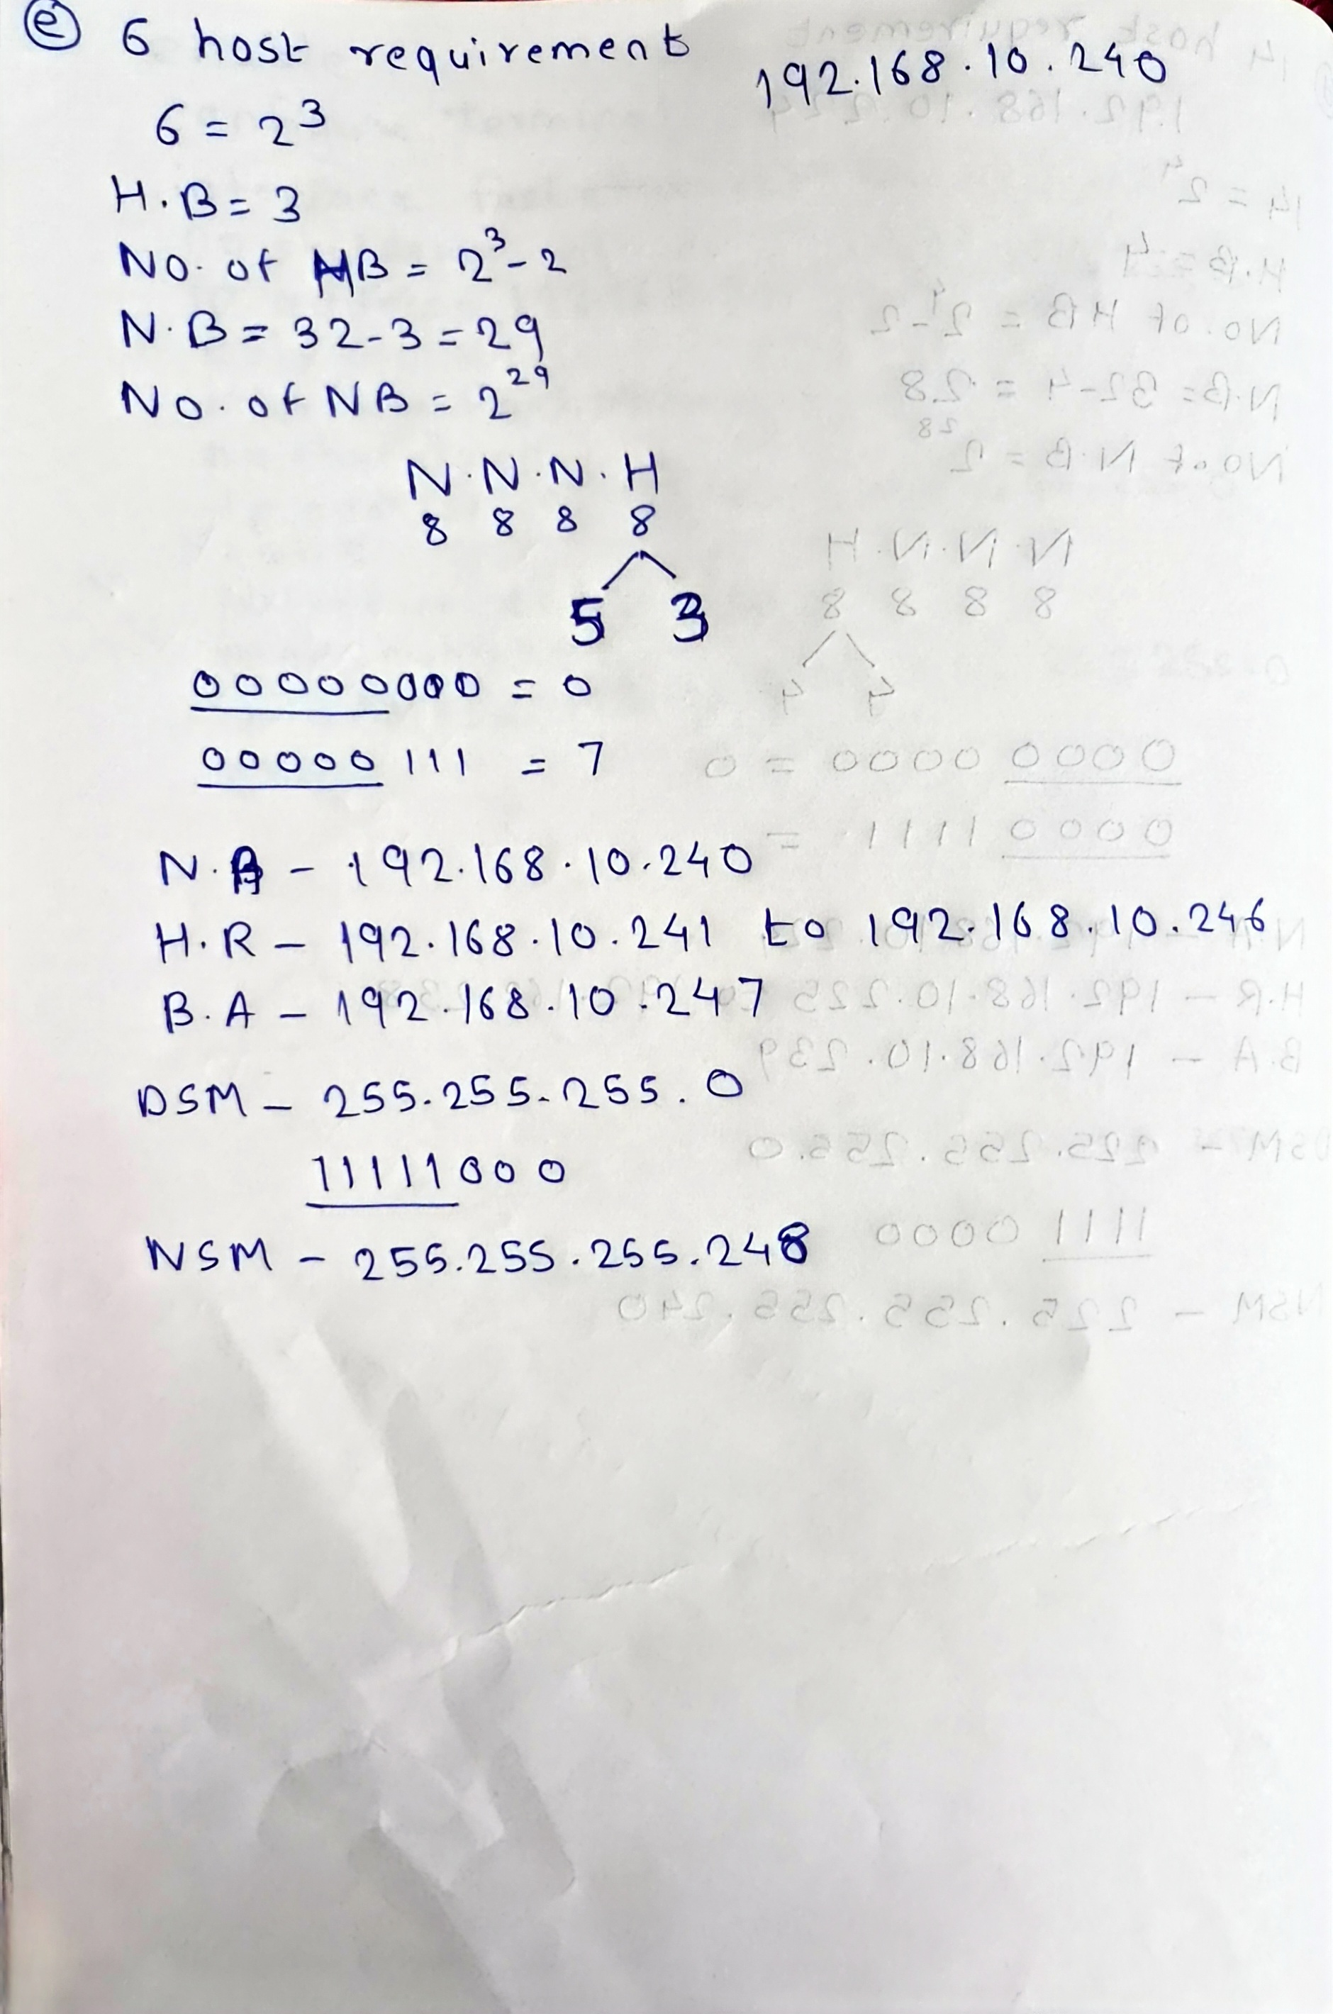
2. A company's IP address is 172.18.0.0/16. They need to create subnets for four sites with host requirements of 8,000, 60, 900, and 2,000. Using VLSM, calculate the network address, subnet mask, usable host range, and broadcast address for each site.
Department/Site | Hosts | Network Address | Subnet Mask | Usable Host Range | Broadcast
Site 1 | 8000 | 172.18.0.0/19 | 255.255.224.0 | 172.18.0.1 – 172.18.31.254 | 172.18.31.255
Site 4 | 2000 | 172.18.32.0/21 | 255.255.248.0 | 172.18.32.1 – 172.18.39.254 | 172.18.39.255
Site 3 | 900 | 172.18.40.0/22 | 255.255.252.0 | 172.18.40.1 – 172.18.43.254 | 172.18.43.255
Site 2 | 60 | 172.18.44.0/26 | 255.255.255.192 | 172.18.44.1 – 172.18.44.62 | 172.18.44.63
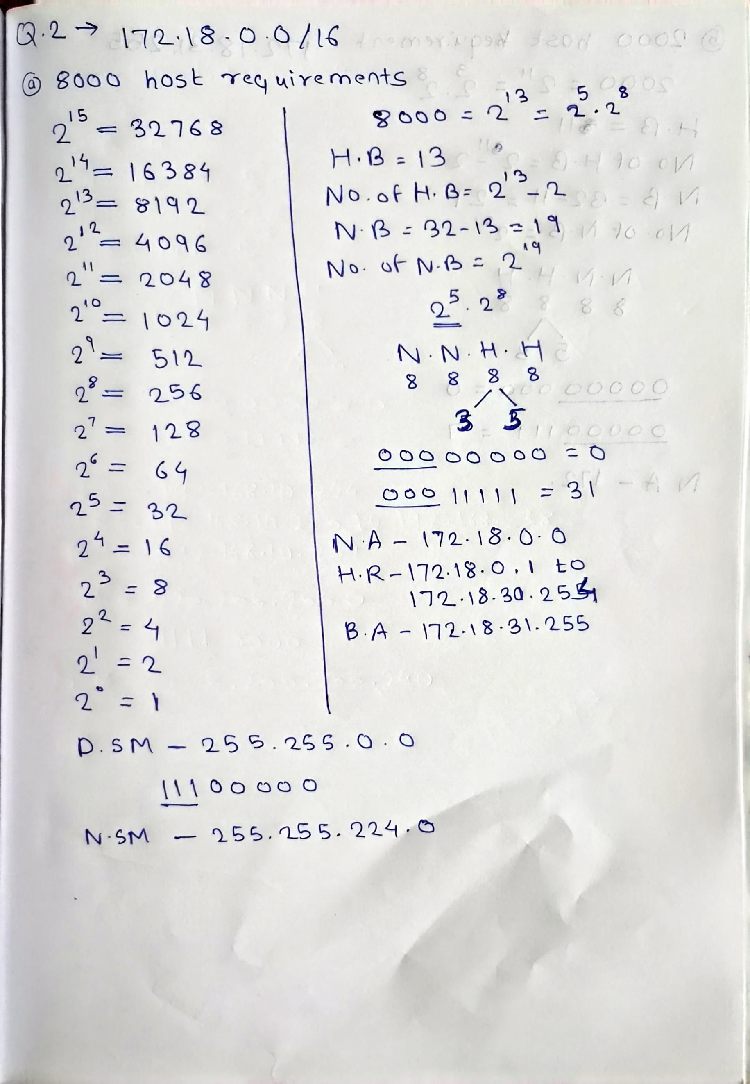
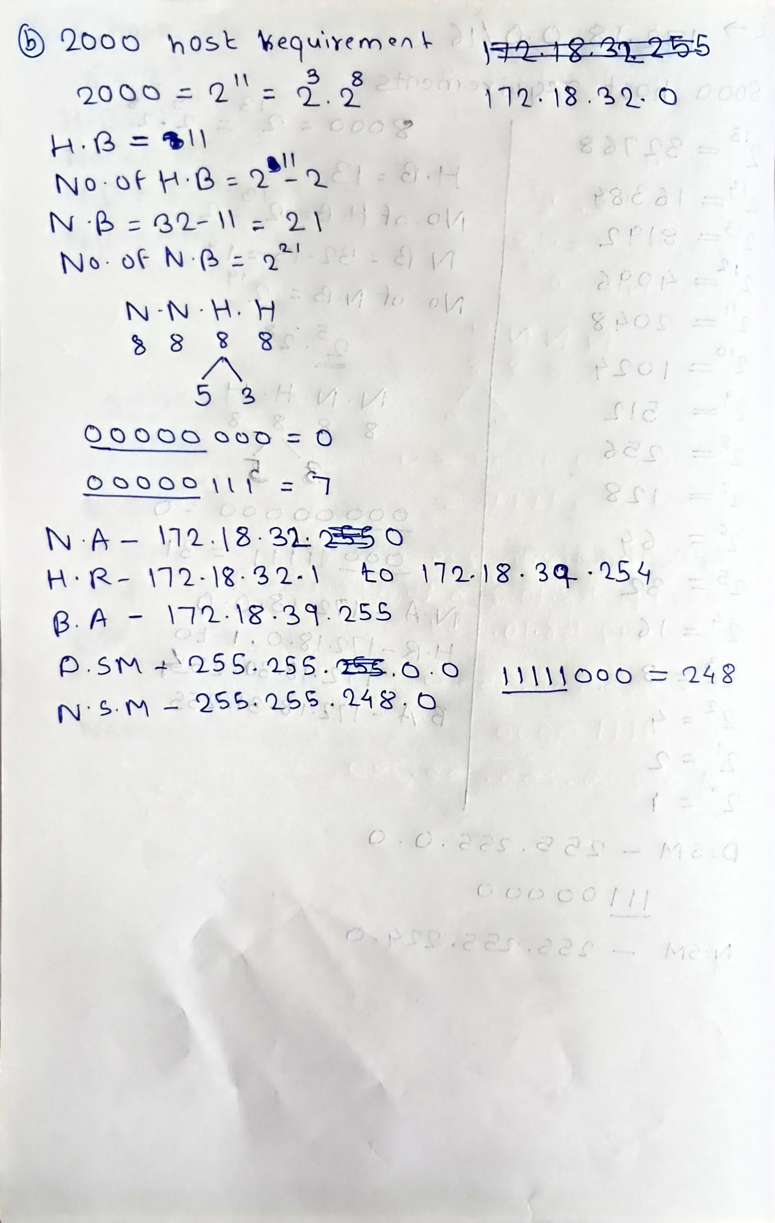
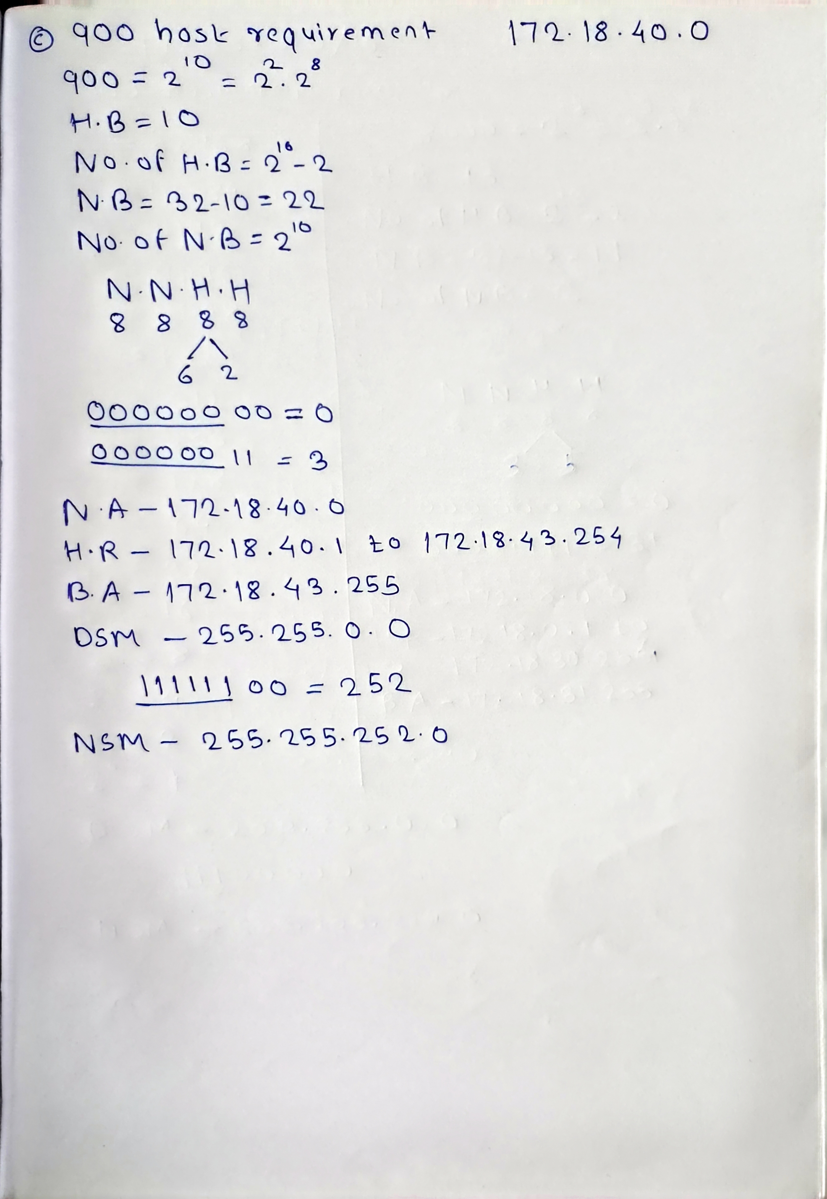
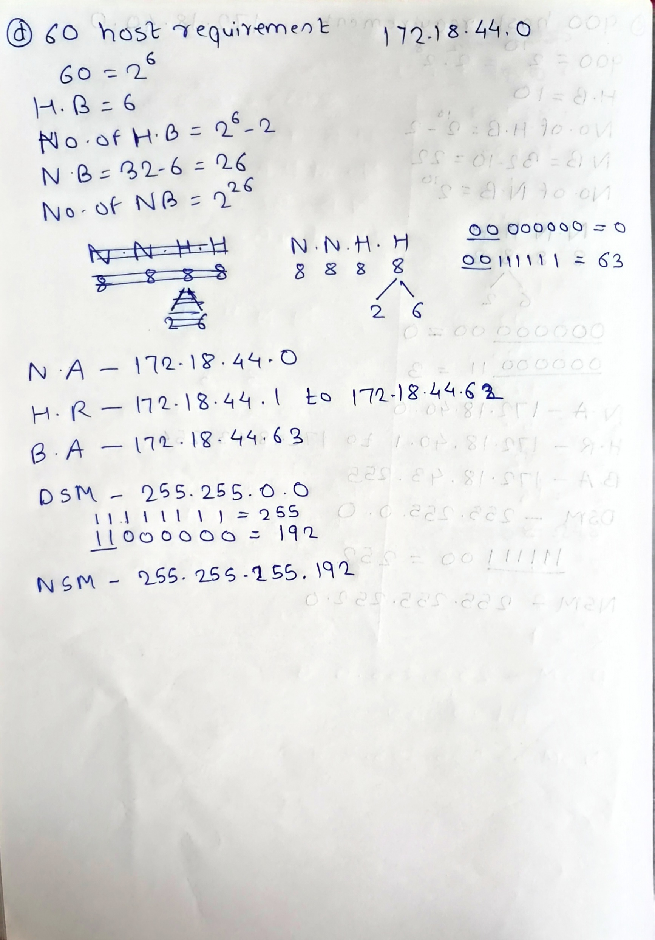
3. Your organization uses the IP address 10.0.0.0/8. You need to create subnets for three branch offices with 50,000, 20,000, and 5,000 hosts. Solve this VLSM problem and provide the subnet details for each office.
Department/Site | Hosts | Network Address | Subnet Mask | Usable Host Range | Broadcast
Branch Office 1 | 50000 | 10.0.0.0/16 | 255.255.0.0 | 10.0.0.1 – 10.0.255.254 | 10.0.255.255
Branch Office 2 | 20000 | 10.1.0.0/17 | 255.255.128.0 | 10.1.0.1 – 10.1.127.254 | 10.1.127.255
Branch Office 3 | 5000 | 10.1.128.0/19 | 255.255.224.0 | 10.1.128.1 – 10.1.159.254 | 10.1.159.255
